# Objectives

* + Install **Active Directory Domain Services** on **SERVER**.

## Skills Reviewed

* + Login with administrative rights.

## New Skills

* + Add a role to Windows.
  + Install **Active Directory Domain Services**.

# Initial Conditions

Your virtual machine should be in this state prior to beginning this guided practice:

* + VM Host Setup Guided practice is complete.
  + HyperV is installed.

# Final Conditions

At the end of this exercise, you will have:

* + VM’s created for **SERVER**, **CLIENT1**, and **CLIENT2.**
  + IP addresses and computer names will be configured on **SERVER** and **CLIENT1**.
  + **Active Directory Domain Services** installed and configured on **SERVER**.

# Create the virtual network and hosts

* 1. On **VMHost**, log in as **Administrator**.
  2. Open **Chrome** and access this course in Canvas,
     1. Navigate to this activity.
     2. Download the **Create-Course-Topology.ps1** file to the **C:\Scripts** folder. This file is a PowerShell script. The script will create the virtual network shown in the image below inside of HyperV.

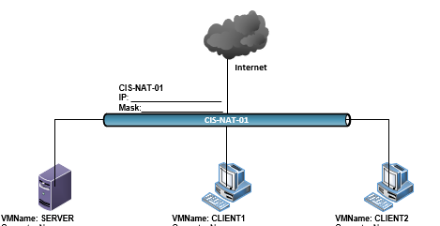

* 1. Execute the script by:
     1. On your **VMHost** machine, open **Powershell**. (**Start** -> **Windows PowerShell**).
     2. In PowerShell, enter the command:

C:\Scripts\Create-Course-Topology.ps1

**Note**: You will see a security warning when running the script. Ener **R** to run the script.

* + 1. You should see output similar to the image below.

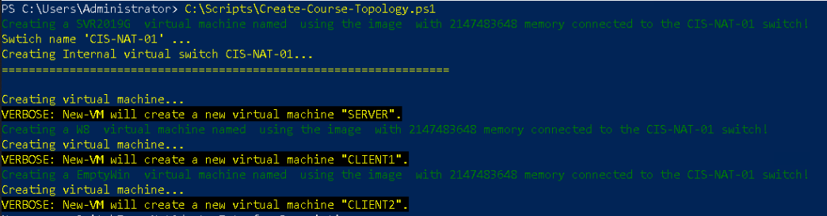

* 1. Verify that the VMs & switch were created.
     1. Open the **Hyper-V management** tool and click on your **VMHost** server. You should see the three VMs: **SERVER**, **CLIENT1** and **CLIENT2**.

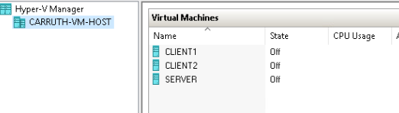

* + 1. In **Hyper-V**, click on **Virtual Switch Manager…** You should see the **CIS-NAT-01** switch. This virtual switch has the special capability to also run NAT. **CIS-NAT-01** is the gateway for all hosts on your network.

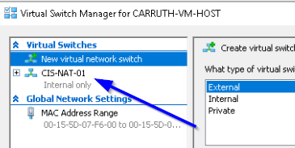

# Access VM & Start

* 1. In **Hyper-V Manager**, in the **Virtual Machines**, double-click **SERVER**. This will open the **SERVER** VM. Note that **SERVER** is turned off.
     1. Click **Start**. This will start the **SERVER** VM. The is the first time **SERVER** has been stared, you will go through the setup process.
     2. On the **Hi There** page, click next
     3. On the **It’s time to enter the product key page**, select **Do this later**.



* + 1. On the **Licensing terms** page, click **Accept**.
    2. On the Customize settings page, enter **Password1** as the **Password** and **Reenter password** fields and then click **Finish**.

**Note**: Do not change this password. This password is needed for some of the scripts to run in the course.

* + 1. Log in to SERVER, (**Action** -> **Ctrl+Alt+Delete**)

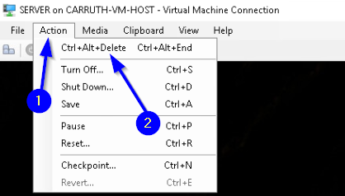

* + 1. Enter **Password1**. Initial **SERVER** access and startup is complete.
  1. In **Hyper-V Manager**, in the **Virtual Machines**, double-click **CLIENT1** and select **Start**.
     1. Log in to **CLIENT1** using account **ecpi** with password of **Password1**.
     2. **CLIENT1** is started and ready for operations.

# Change computer name and ip address

**Note**: References are included in some steps for skills learned in previous courses. If you have forgotten the skill, please use the reference to refresh your memory.

* 1. Rename **CLIENT1** and **SERVER** to the name you planned in the **Network Diagram** activity. **Hint**: Right click **Start -> System -> Change settings -> Change**

References: <https://technet.microsoft.com/en-us/library/dd894434(v=ws.10).aspx>

* 1. Rename the network adapters (NIC) in **CLIENT1** and **SERVER** virtual machine (VM) to **LAN**. **Hint**: Right click **Start -> Network Connections**

Reference:<https://support.microsoft.com/en-us/help/2729523/how-to-rename-a-network-adapter-in-windows-8-or-in-windows-server-2012>

* 1. Set the IPv4 address on **CLIENT1** and **SERVER** as you planned in the **Network Diagram** activity.
  2. Set the **Preferred DNS server** address on the **LAN** NIC for **CLIENT1** and **SERVER** to be the **LAN** NIC IPv4 address of the **SERVER**.

# Install Active Directory

* 1. On **SERVER**, log in as **Administrator**.
  2. Install **Active Directory Domain Services** on the ***SERVER.***
     1. On **Server Manager Console** toolbar, select **Manage**, and click **Add Roles and** **Features**.
     2. The **Add Roles and Features Wizard** appears displaying the **Before you begin** page. Click **Next**.
     3. The **Select Installation Type** page appears. Select **Role-based or feature-based installation** and then click the **Next**.
     4. The **Select destination server** page appears. Click **Next** to accept the default local server.
     5. The **Select server roles** page appears. Select the **Active Directory Domain Services** check box. The **Add Roles and Features Wizard** page pops up. Click **Add Features** button and then click **Next**.
     6. The **Select features** page appears. Click **Next**.
     7. The **Active Directory Domain Services** page appears. Click **Next**.
     8. The **Confirm installation selections** page appears. Click **Install** to start **Active Directory Domain Services** installation process.
     9. Wait for the installation process to complete and then click the **Close**. **Note**: This process takes a while – be patient).
     10. On **Server Manager** on the toolbar, a yellow warning message will appear. Click on it. (If you do not see the yellow triangle, refresh **Server Manager** by clicking on the icon to the right of the dropdown arrow.)

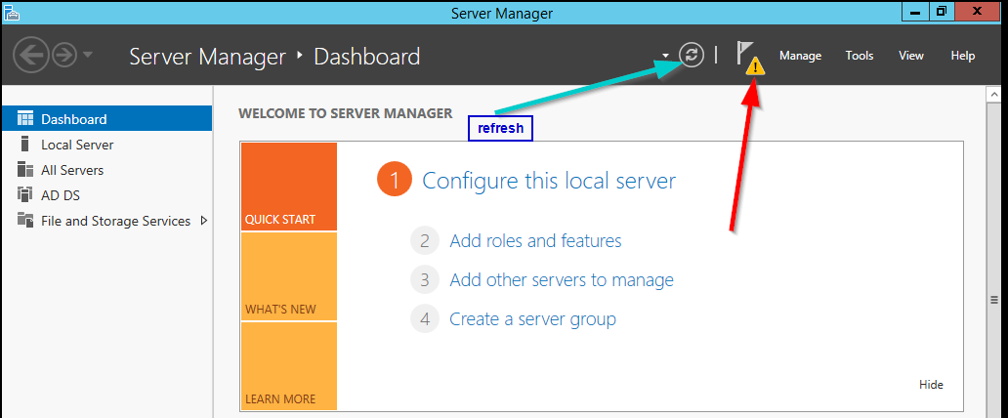

* + 1. After clicking on the yellow notification, a popup will appear with a link **Promote this server to a domain controller**. Click that link.

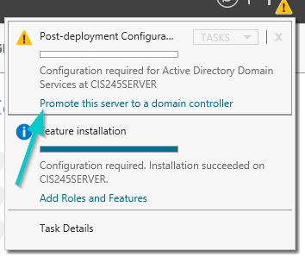

* + 1. The **Deployment Configuration** page displays. Select **Add a new forest**. In the **Root domain name:** box enter the **kmk.local** and then click **Next**. This step may take a few minutes to complete.
    2. The **Domain Controller Options** page displays. In the **Password:** and **Confirm password:** boxes enter **Password1** and then click the **Next** button.

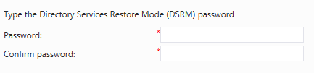

* + 1. The **DNS Options** page appears with a warning at the top. Click **Next** to continue.
    2. The **Additional Options** page appears. The **NetBIOS domain name:** box is prepopulated. **Observe** the name. Why you think the installation process chose this name? Accept the default name and then click **Next.**
    3. The **Paths** page appears. Accept the defaults and click **Next** to continue.
    4. The **Review Options** page appears. Click **Next** to continue.
    5. The **Prerequisites Check** page appears. Click the **Install** button to proceed with **Active Directory Domain Services** installation. This step may take a few minutes to complete.
    6. After installation is complete, acknowledge system restart.

1. After **SERVER** restarts, login into **SERVER** as **administrator** in your domain. What is different about the login screen?
2. On **Server Manager** toolbar, select **Tools > Active Directory Users and Computers**. Expand your domain, **kmk.local**, and click **Domain Controllers**. You should see **SERVER** in the details pane.

# Join CLIENT1 to Domain

1. Log into **CLIENT1**
2. Open **System** properties. (Right-click **Start** and select **System**).
   * 1. On **System**, click **Change Settings** button
     2. The **System Properties** page opens. On the **Computer Name** tab, click **Change**.
     3. Click the **Domain radio** button, then enter your assigned domain name of **kmk.local** and click **OK**.
     4. Use the **Administrator** account for the domain you just created. This account is the one authorizing the computer account creation in the domain.
     5. Close screens and reboot **CLIENT1**.
3. After reboot, notice the difference ion the logon page. What is the portion of the name that is located before \**ecpi**?

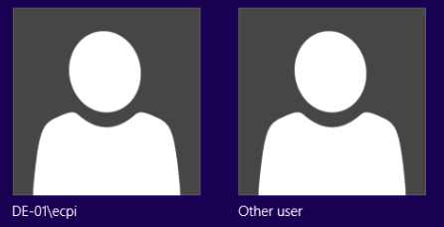

1. Log in with the **DE-01\ecpi** account. Yes, you can still log in with local accounts.
2. Log out of **CLIENT1**.
3. Login to **CLIENT1** using **KMK** domain Administrator account.
   1. Click **Other User.**
   2. Enter **Administrator** as the **Username**. Note that the **Sign in to:** changed from **KMK** to **DE-01**. When logging into the domain with a username that also exists on the local system, you must specify the account location that you are logging in with. Add **KMK\** in front of the **Administrator** username and then enter the password  
      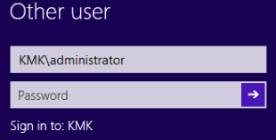

# Configure DNS to access ECPI Internal DNS

**Note**: This configuration is an **optional step**. Many of you would like to access your campus portal page from within the VMs inside of Hyper-V.

1. Log into **SERVER** as administrator.
2. Open **PowerShell(Admin)**.
3. Issue the command:

Add-DNSServerForwarder -IPAddress 10.254.7.1

1. Verify that you can access your Campus Portal page from **SERVER**. (i.e. <http://grvl.ecpi.edu>).

# ACTIVATE VMS

1. The KMS server for ECPI is located at **10.10.6.20**. In **Windows PowerShell (admin)** on **SERVER** and **Command Prompt (Admin)** on **CLIENT1**. Issue the following commands to activate **SERVER** and **CLIENT1** systems.

slmgr /skms 10.10.6.20

slmgr /ato

The expected response is **Product activated successfully**.

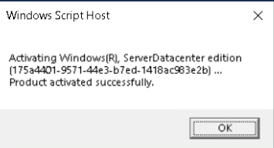

1. If the response from **slmgr /ato** is ***The activation server determined that the specified product key could not be used***, issue the following commands to add the correct product key to the VM so that it will activate.

slmgr /ipk WMDGN-G9PQG-XVVXX-R3X43-63DFG (Server)

slmgr /ato

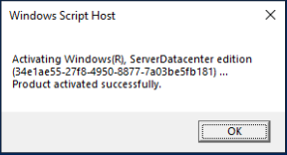

# Document Work

1. On your **VMHost** system, **download** the **grading** **script** from the assignment page to the **C:\Scripts** folder.
2. Check your lab by running the following command:

Invoke-Pester -Path C:\Scripts\GP02-Installing_Active_Directory. Test.ps1

**Note**: you will see a security warning when running the script. Ener **R** to run the script.

If you want to see more detail, add **-Output Detailed** to the command. This may assist you with troubleshooting

Invoke-Pester -Path C:\Scripts\GP02-Installing_Active_Directory. Test.ps1 -Output Detailed

1. You should not see any red in the output. Red in the PowerShell way of telling you that an error condition exists. Most of the time, the output will tell you what is wrong. If it is not obvious, contact your teacher and ask for assistance. You will be learning PowerShell during this term. **Correct** any **errors** you may have and run the script until all the output has no red. You should see the output like the images below.

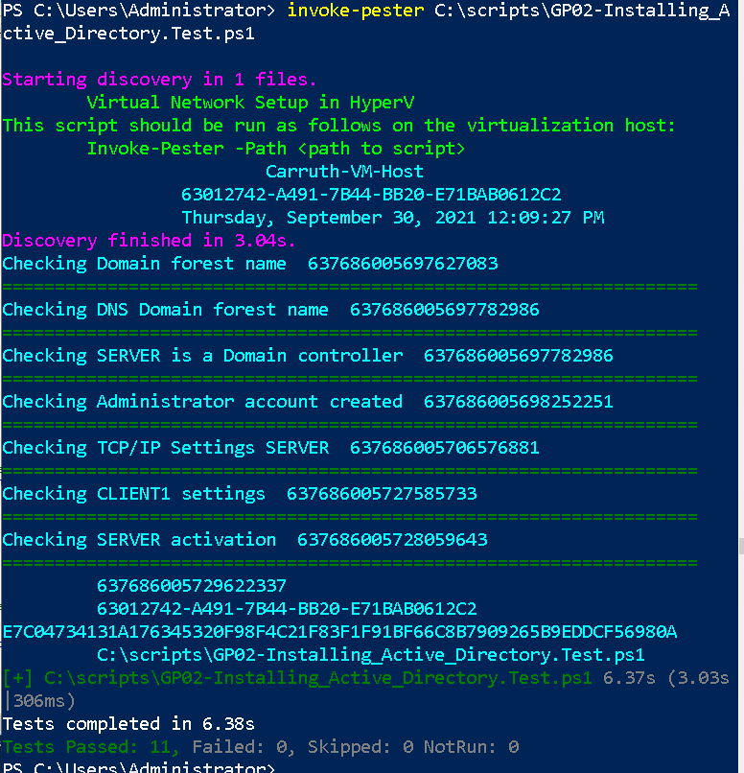

1. Capture a snippet that shows the PowerShell Command and all its output. If you must use more than one snippet to capture the output, you must have at least **one line of overlap** in the snippets. The text in the snippets **must be legible** when pasted into the Word document. Paste the snippet(s) into the **VirtualNetwork_Setup_*FirstName*_*Lastname*.docx** report. The snippet should look like the image above.
2. **Upload** your **VirtualNetwork_Setup_*FirstName*_*Lastname*.docx** report in the submission area for the assignment.